
Copley township
ARCHITECTURAL REVIEW BOARD

Jacoby road parcels 1501734, 1501735, 1503826

multi family: r-cd
staff report
  - November 1, 2021
PROJECT: Jacoby Multi Family; Rezoning Residential Conservation Development (R-CD)  Parcels 1501734, 1501735, 1503826 (1625 Sunnyacres Road) | APPLICATION TYPE: Jacoby Road Multi Family; R-CD-Major Site Plan  Plan Submitted: 10/12/2021  Plan Updates: 10/26/2021: CED Comments; SSWCD Comments; 11/1/2021: ORAM, Tree Survey Summary Letter
APPLICANT/LANDOWNER | APPLICANT: Ben Weinerman, Pride One Construction  LANDOWNER: Jacoby Company (PPN: 1501734, 1501735)  Rolling Wood LLC (PPN: 1503826 (1625 Sunnyacres Road)-Parcel utilized for access and utilities off of Sunnyacres Drive)
COMPANY PERFORMING WORK REQUESTED | Pride One Construction
INVESTMENT | $25,000,000
APPLICATION SUMMARY | Applicant, Ben Weinerman, on behalf of Pride One Construction, is requesting review of a multi-family development project consisting of 133 attached single family dwellings.  The applicant will require a rezoning of the existing parcels to permit the R-CD (Residential Conservation Development) overlay in the R-MD (Residential-Medium Density).
INITIATED BY | Applicant
DECISION TYPE | ☒Informational  ☐Direction  ☐Action
CODE REFERENCES | Article 3, Section 3.06 R-CD (Conservation Development) Residential District
GENERAL LOCATION | Parcels 1501734 and 1501735 are located on the east side of Jacoby Road, south of Copley Road and north of Wright Road.  Parcel 1503826 (1625 Sunnyacres Road) is located on the west side of Sunnyacres, east of Lawnshire Drive and south of Wealthy Drive.
ACREAGE | The project site encompasses 63 acres of residentially zoned land.
ZONING | R-MD (Residential Medium Density)
AGNECY REVIEW | Army Corp of Engineers  City of Akron Sewer  City of Akron Water  Copley Township Department of Community & Economic Development  Copley Township Fire  Copley Township Police  Copley Township Service  Summit Soil & Water Conservation District  Summit County Engineers Office
ADDITIONAL STUDIES/PLANS | Wetland Delineation-Jurisdictional Determination-A preliminary JD has been issued for this project and submitted to the Summit Soil & Water Conservation District for review.  Traffic Impact Study-A Site Distance Diagram and Traffic Impact Study have been submitted to the Summit County Engineer’s Office for review.  Noise-The applicant conducted a voluntary noise study due to proximity of the Copley Trap Range. Results conclude that disturbance is inside the permitted decibel levels per the Summit County Noise Ordinance. Noise will be audible outside of the residence. Audibility inside of the resident is unlikely with other factors including construction of the home materials, windows opened/closed. STAFF RECOMMENDATION: Installation of double or triple hung windows  Down Stream Sanitary Lift Station Capacity Study-Submitted to the Akron Engineering Bureau for water and sewer serviceability.  Tree Preservation Plan-The applicant has prepared a cursory Tree Survey for review and consideration by the Architectural Review Board
SITE VISIT CONDUCTED BY ARB | TBD
STAFF RECOMMENDATION | Continue review pending agency approval.

property location
SITE | ZONING | LAND USE
North | R-MD | Conditional-School; Residential
South | R-MD | Residential
West | R-MD | Residential
East | R-MD | Residential

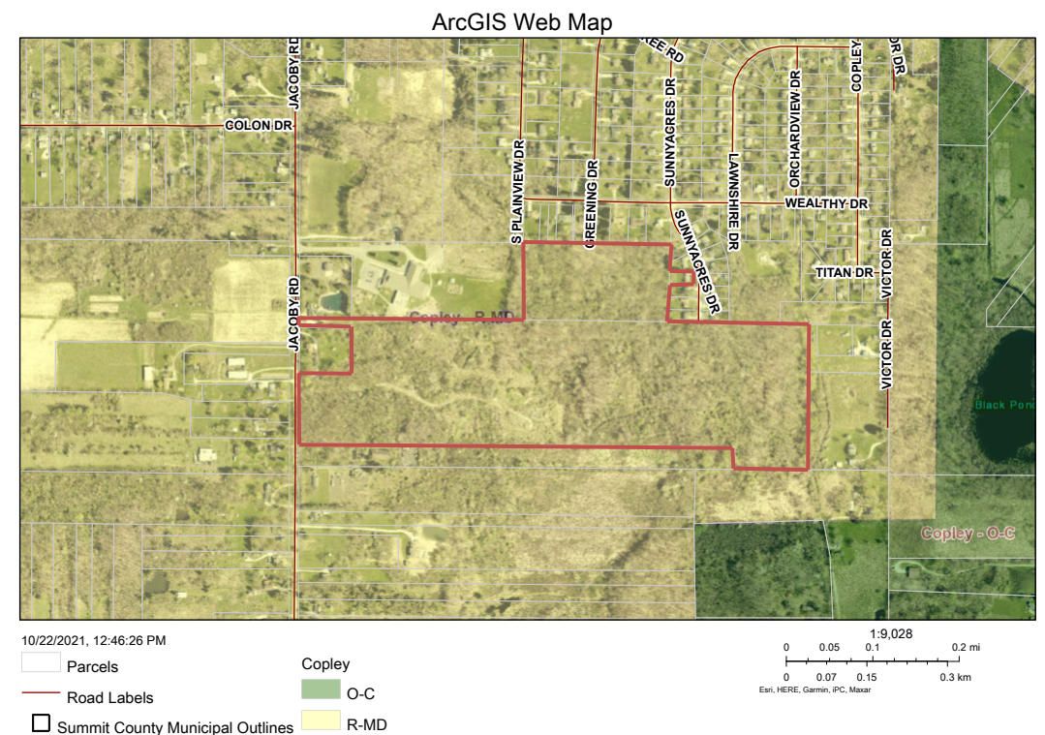

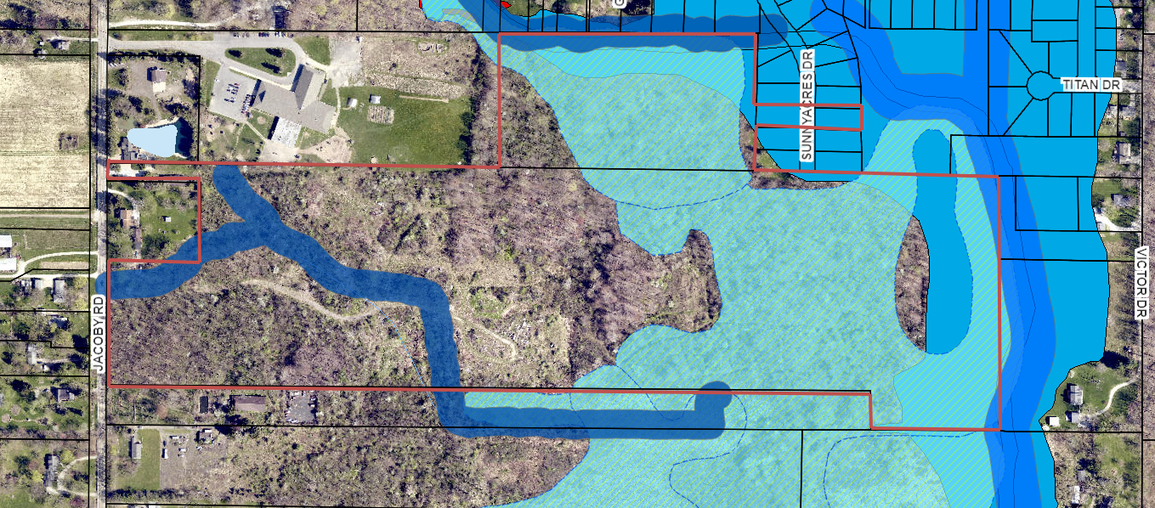

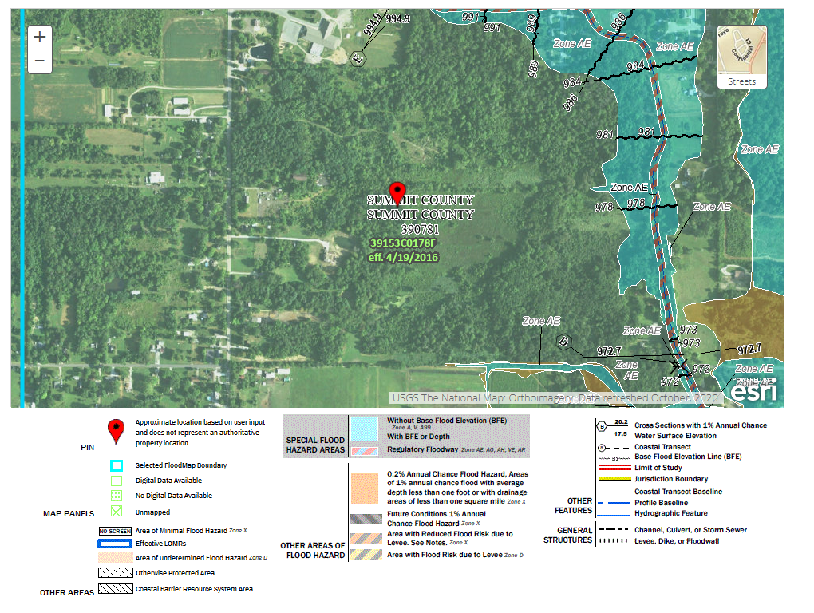
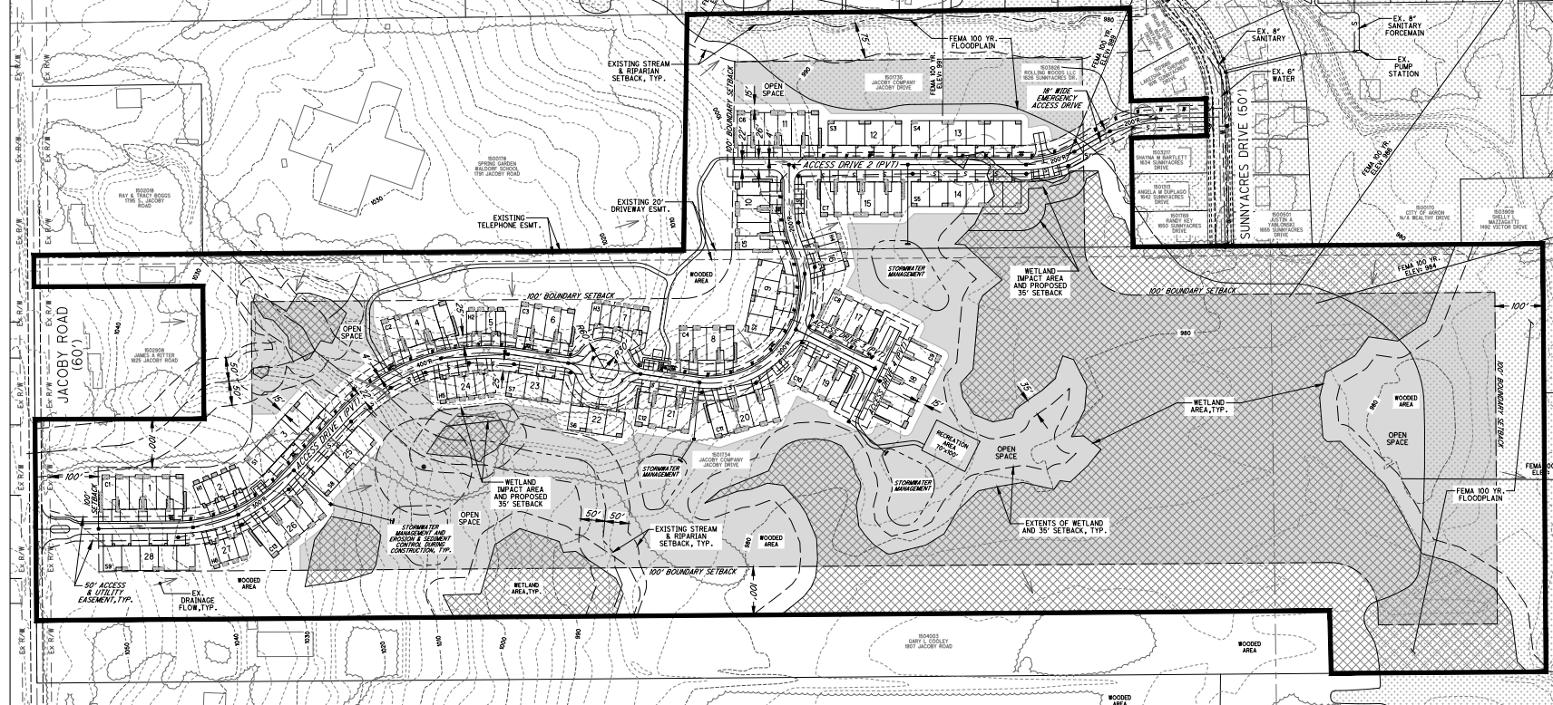

PROJECT BACKGROUND AND DESCRIPTION
Applicant, Ben Weinerman on behalf of Pride One Construction has submitted a Major Site Plan application for the development of 63 acres of land located on Jacoby Road for the purpose of constructing 133 attached single story and two-story residential dwellings.

A General Development Plan has been submitted for review and will require a Map Amendment of the parcels. The amendment permits the Residential-Conservation Development (R-CD) regulations overlay on this parcel which is zoned Residential-Medium Density (R-MD). The R-CD regulations may be applied to any residential zoning district.

The parcels are restricted by wetlands/Riparian. A formal Wetland Delineation has been submitted for this project. Per the preliminary Jurisdictional Determination, the site is comprised of 19.27 acres of six (6) wetlands and 2,905 linear feet of seven (7) streams. The applicant anticipates disturbance of less than 1 acre of identified wetlands.

General Regulation Highlights
Per Article 3, Section 3.06, the applicant must provide for the following regulations:

- 152 Maximum Units Permitted. 133 Units Proposed.
- 104 single story units (Sanibel, Windsor, Canterbury); 29 two story units (Havana)
- 100’ setback from project boundary: The plan calls for a 100’ setback from all property lines.
- 40% open space: The plan calls for 45% open space (29.3 acres).
- 15’ minimum building separation: The plan calls for 20’ building separation.
- The applicant has proposed the construction of a private driveway for unit access. The buildings will be setback 25’ from the edge of pavement of the private drive.
- 22 guest parking spaces
- Project features proposed inside of the Open Space: (3) Storm water basins, (1) 7000 square foot recreation area
- Sidewalks will be inlayed in the roadway
- Street lighting-TBD

The Site Plan review will follow the procedure set forth under the Ohio Revised Code 519.021 (A) Planned Unit Development https://codes.ohio.gov/ohio-revised-code/section-519.021 and the Copley Township Zoning Resolution, Article 3.06 https://www.copley.oh.us/DocumentCenter/View/126/Article-3-Residential-Districts-PDF (beginning on Page 15).

- Submission & Review of General & Final Development Site Plans by the Architectural Review Board
- Submission plan review and preliminary approval by all reviewing agencies of the Development Plans
- Final Plan approval by the ARB
- Submission of a Map Amendment Application to the Board of Trustees based on the approved development plan
- Public Hearing and Motion on proposed Map Amendment to incorporate the overlay zoning of the R-C/D

ELEVATIONS

WINDSOR/CANTERBURY
- Single Story-64 Units
- 64’ x 28’
- Shake and Board on Batten Siding, Garage Light Fixtures, Stone Veneer
- Double Car Garage

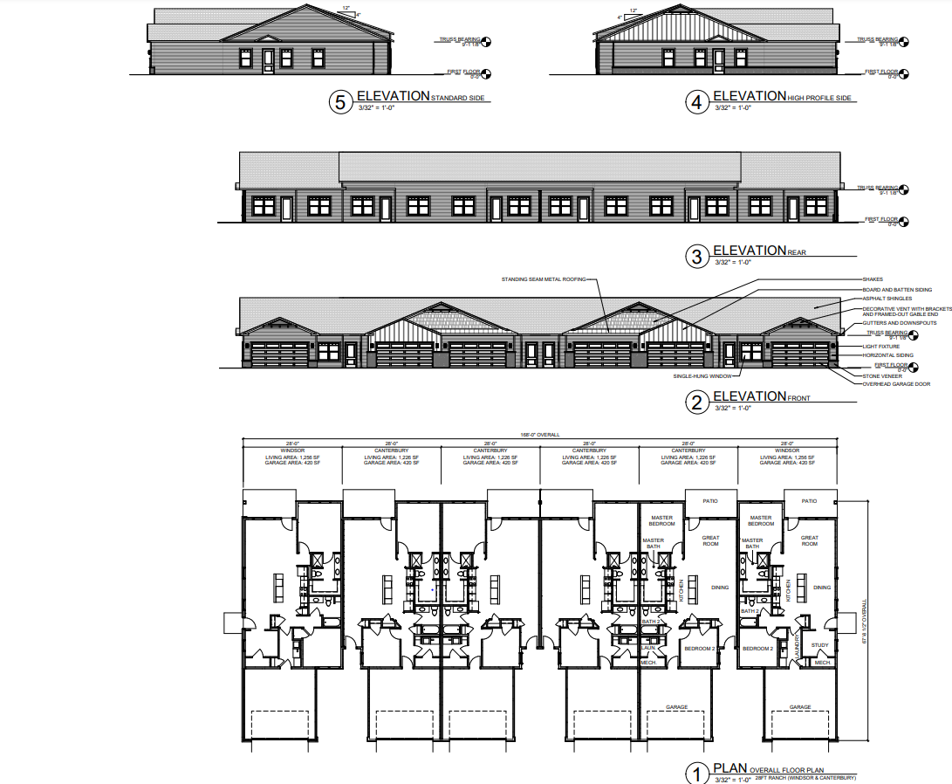

SANIBEL
- Single Story-40 Units
- 52’ x 38’
- Shake and Board on Batten Siding, Garage Light Fixtures, Stone Veneer
- Double Car Garage

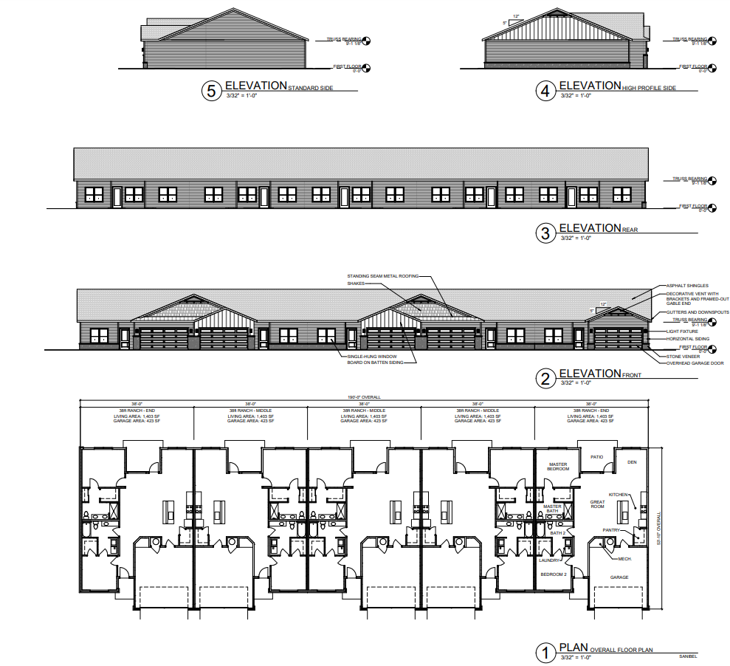

HAVANNA
- Single Story-29 Units
- 46.5’ x 20’
- Shake and Board on Batten Siding, Garage Light Fixtures, Stone Veneer
- Single Car Garage

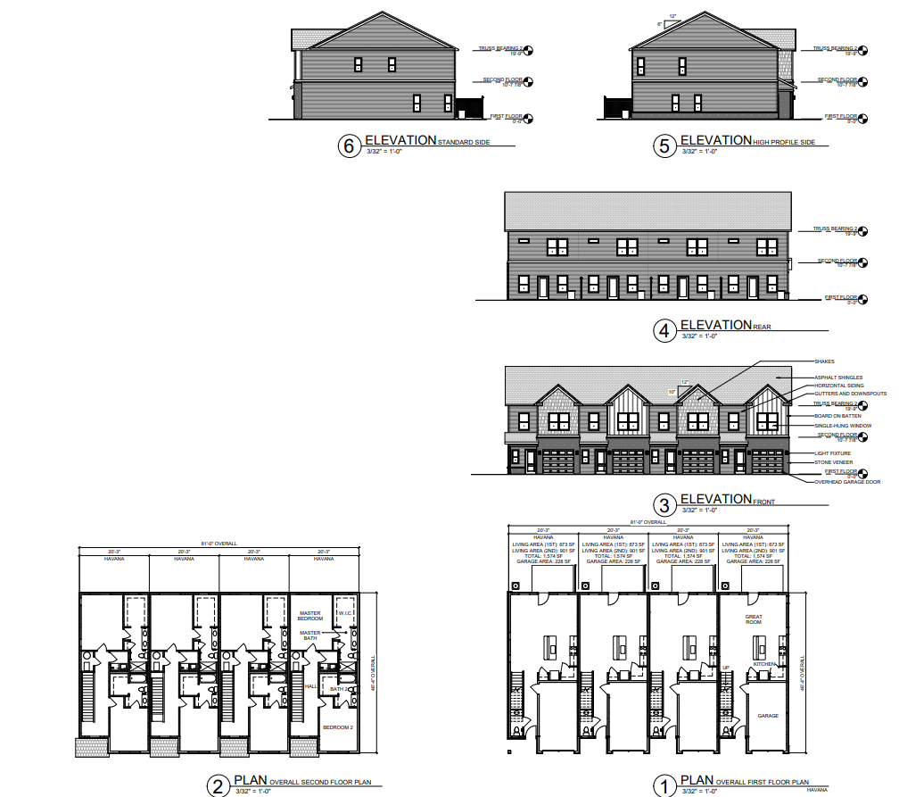

TREE SURVEY

A preliminary Tree Survey has been submitted for review by the Architectural Review Board. The applicant has completed a select sample survey of 122 trees located inside of the identified wetland areas and outside of the identified wetland areas for quality comparison.

Plots 1 & 2 are located inside of the wetland area and outside of the project development boundary.

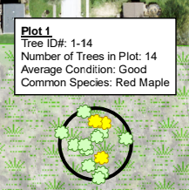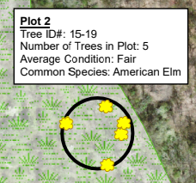

Plots 3, 5 and 6 are located outside of the project development boundary and outside of the wetland area.

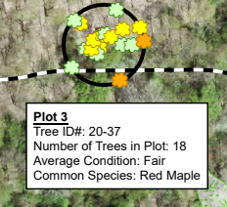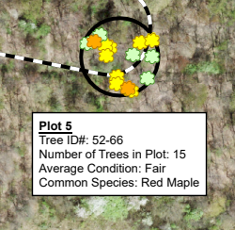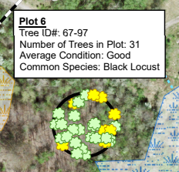

Plots 4, 7 and 8 are located inside of the project development area and outside of the wetland area.

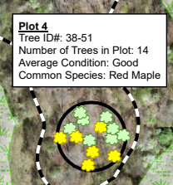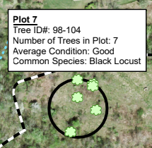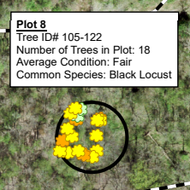

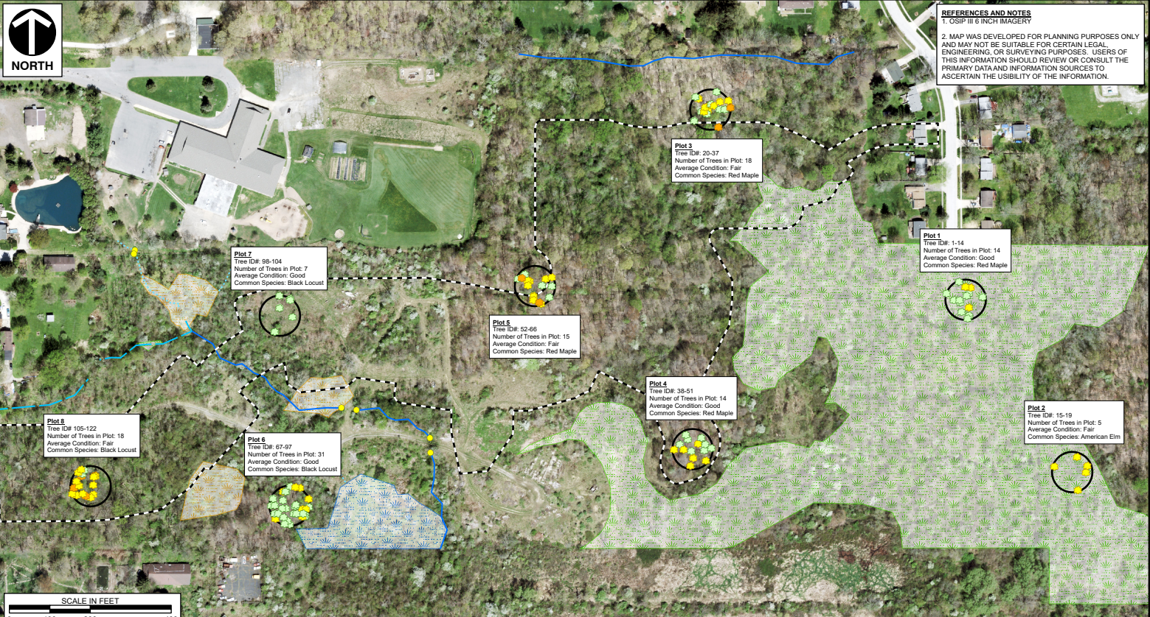

FINDINGS PROPOSED BY THE APPLICANT

On September 24, 2021, Civil & Environmental, Inc. (CEC) staff conducted point-count tree surveys at the proposed Pride One Construction – Jacoby Road development (the Site) to collect descriptive information on general forest habitat, observed tree species, and tree canopy. The investigation documented existing trees greater than or equal to six inches in diameter at breast height (DBH) within eight, 50-foot radius plots across the Site. Tree locations were collected with a Trimble R1 GPS unit and a wooden stake flagged with survey tape was installed to mark the center of each plot.

Tree survey plot locations were chosen using aerial imagery prior to the tree survey site visit and receipt of the proposed limits of disturbance (LOD) and were intended to represent the general conditions of ‘woodland habitat’ across the Site. Following the receipt of the proposed LOD from Pride One Construction on October 11, 2021, CEC determined that four plots were located within the proposed LOD and four plots were generally located within the proposed preservation area.

Based on the findings of the tree survey and as depicted on Figures 1 and 2 (attached), CEC is of the opinion that the woodland habitat and the canopy cover and quality across the Site is generally consistent in both the areas proposed for disturbance and preservation. No observable differentiation between woodland habitat or canopy quality was documented between the proposed development and preservation areas.

According to Article 16.02(B) of Copley Township Code (Article 16), residential developments must preserve a minimum of fifty percent of ‘woodlands’ on site. Since the proposed preservation of ‘woodland habitat’ on site is expected to meet the fifty percent threshold based on mapping provided by Pride One Construction, the proposed tree canopy to be preserved adequately supports the requirements outlined in Article 16.

LANDSCAPE PLAN

To be submitted at a later date.

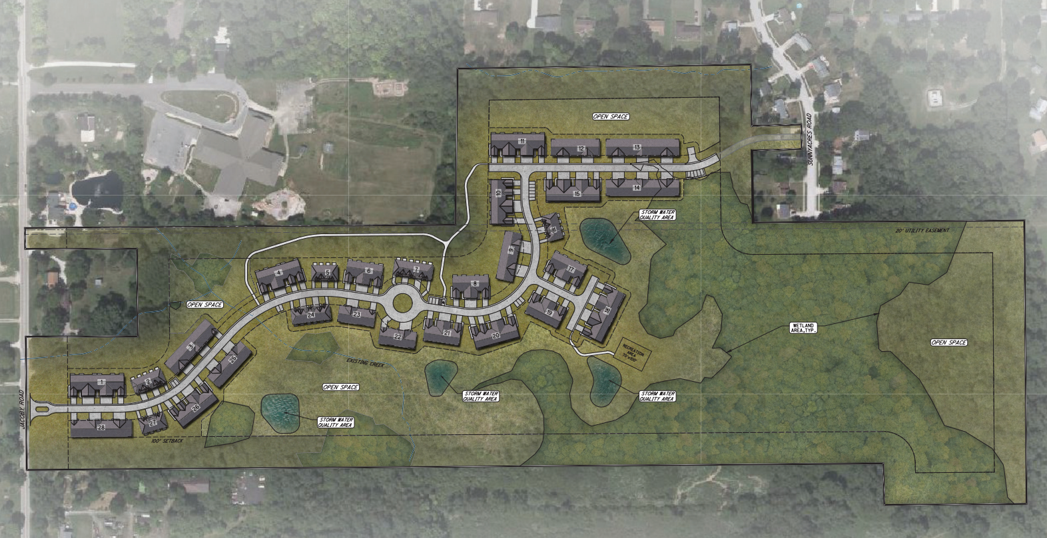

ARTICLE 3.06 R-CD (CONSERVATION DEVELOPMENT) RESIDENTIAL DISTRICT
A. Purpose and Authority The primary objective of conservation development zoning is to promote the health and safety of the community through the application of flexible land development techniques in the arrangement and construction of dwelling units and roads. Such flexibility is intended to maximize the conservation of open space while accepting development and retaining for the property owner the development rights (the number of residential dwelling units) that are permitted under the existing conventional zoning for the property. These regulations may be applied in any Residential zoning district, as specified below, and are intended to achieve these corollary purposes: To maximize protection of the community’s natural resources by:
1. Avoiding development on and destruction of sensitive natural resource areas;
2. Reducing the quantity and improving the quality of storm water runoff from expected development;
3. Maintaining natural characteristics (such as woods, hedgerows, natural vegetation, meadows, slopes and streams);
4. Reducing the amount of disturbed land, the conversion of natural areas to landscaped areas for lawns, and discouraging the use of plants that are non-native invasive species; and
5. Conserving areas of prime agricultural soils, to the extent possible.
6. To conserve (within the framework of natural resource conservation) the quality of ruralness in a community which is characterized by: a. Large, aggregated, undeveloped land areas; b. Natural features such as woodlands, steep slopes, floodplains, wetlands, stream and river corridors, hedgerows and rock outcroppings; c. Scenic vistas and rural views; d. Significant historic features such as old barns, heritage trees, etc.; e. Traditional rural settlement patterns characterized by clusters of compact groupings of development in otherwise wide open spaces; and/or f. Appropriate topographic or vegetative screening.
7. To encourage more efficient use of land and public services through unified development.
8. To establish development review criteria which promote creative design solutions in a manner which best conserves the area’s resource
9. To establish a review process which maintains local review and approval of the overall development plan and which results in the timely consideration of an application.
10.To ensure that the proposed Conservation Development complies with the objectives of Copley Township as expressed in this Township Zoning Resolution and the Township Comprehensive Land Use Plan. These regulations are established under the Authority of O.R.C. §519.021(A), Planned Unit Development

EXTERNAL REVIEW CRITERIA
AGNECY REVIEW
ARKON ENGINEERS BUREAU | Sanitary Sewer Lift Station Capacity Review
ARMY CORP OF ENGINEERS | Wetland Delineation-Jurisdictional Determination
CITY OF AKRON SEWER | Private sanitary
CITY OF AKRON WATER | Private water line looped; Sunny acres Drive via Jacoby Road
SUMMIT SOIL & WATER CONSERVATION DISTRICT  Wetland Delineation | 10/27/2021  - ORAM information has not been provided. This is required per the riparian setback ordinance and is used to determine the additional buffer distance placed around riparian wetland areas. The ORAM is required to be approved by the Ohio EPA; this item should be addressed prior to the issuance of any variances or other approvals.  11/1/2021 ORAM submitted by applicant for review  - The site plan shows a “35-foot setback” around the wetland areas. This is not a setback width identified in the riparian setback ordinance (30’ setback for category 2 wetland, 50’ setback for category 3 wetland). The applicant would need to apply for a variance with the Township BZA to seek a reduction to the required setback distance or use the required wetland buffer distances as per the riparian setback ordinance.  - Some areas of the building footprint abut the riparian area and wetland buffer. It appears that adequate distance has not been provided to ensure construction equipment, grading, etc. can move around the building without impacting the riparian setback and wetland buffer. With that, it’s reasonable to assume construction of the buildings will impact the riparian area and wetland buffer in these areas. This type of impact is not permitted per the riparian setback ordinance. The applicant would need to apply for a variance with the Township BZA for the proposed impact, or the building locations should be relocated to ensure adequate distance between buildings and riparian/wetland buffer areas are provided for construction (showing adequate distance for construction on site plans is also acceptable).  - The current site plan proposes impact to riparian wetland area for placement of roadway and buildings in the upper north portion of the site. This type of impact is not permitted per the riparian setback ordinance. The applicant would need to apply for a variance with the Township BZA for the proposed impact or seek an alternative location which avoids impact to the riparian wetland areas.  - There is an emergency access drive to Sunnyacres Road that is proposing impact to riparian and FEMA floodplain area. This type of impact is not permitted per the riparian setback ordinance. The applicant would need to apply for a variance with the Township BZA for the proposed impact or seek an alternative location which avoids impact to the riparian wetland areas.  - The applicant is subject to County Chapter 941 and Ohio EPA NPDES General Construction permit. A formal SWPPP will need to be developed and sent to this office for review. Copies of all applicable local, state, and federal approvals/permits for impacts to surface water and/or riparian area will be required. Post construction water quality treatment is also required.
SUMMIT COUNTY ENGINEERS OFFICE
Traffic Impact Study

INTERNAL REVIEW CRITERIA

REVIEW
COPLEY CED | The Community and Economic Development Department is in support of the applicants proposed request for application of the Residential Conservation-Development (R-CD) overlay zoning classification for the parcels in question. The proposed development plan associated with the overlay zoning request is being recommended for continuation to evaluate and receive comments from external agencies, and continue review of environmental and traffic and access related reports. The purpose and intent of the R-CD classification (as outlined in the staff report) in our professional opinion would be applicable for these parcels in particular due to the presence of environmental sensitive acreage and underlying residential zoning classification currently on the parcels. The development guidance the R-CD gives is to allow for unique development patterns, setbacks, and clustering of units on the land less sensitive in an arrangement that would not be permissible in other residential districts to strike a balance of the development potential of the entire acreage, while ensuring those environmental areas are protected for the health, safety, and welfare of the community.
COPLEY FIRE | Two ingress/egress required; Turn around
COPLEY POLICE | Off-street parking; site distance onto Jacoby
COPLEY SERVICE | Private maintenance-Nothing additional required; Request that the roads are constructed to county standards; Consideration for snow storage
ARCHITECTURAL REVIEW BOARD | Review and approval of the Final Development Plan, inclusive of landscape, Tree Preservation.
BOARD OF ZONING APPEALS | A variance from the Common Drive regulation may be required for this project. A variance from Article 15-Riparian Regulations may be required for this project.

SUGGESTED MOTIONS and Authority to Proceed
The Copley Township Architectural Review Board moves to continue review of the General Development Plan.

